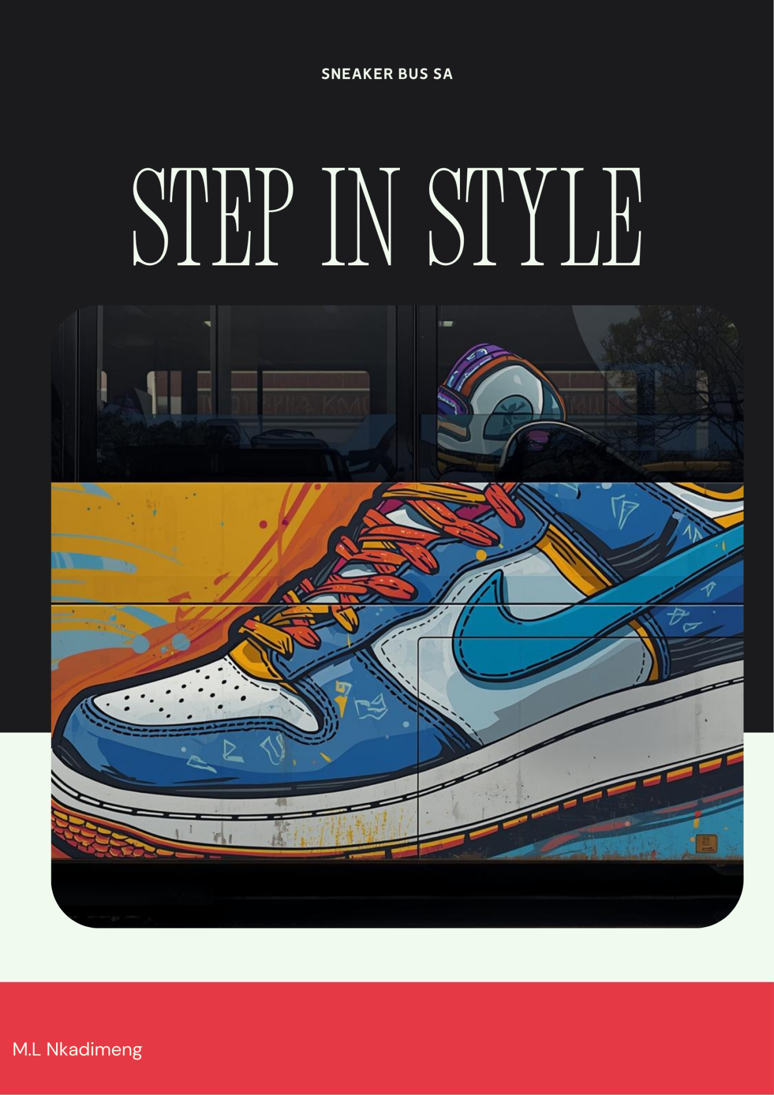

1. Organisation Overview

Name
Sneaker Bus SA

Brief History of the Organisation
Sneaker Bus SA was established to deliver stylish and affordable sneakers directly to communities via a mobile retail unit housed in a bus. The concept was inspired by the rising trend of sneaker culture and the desire for fashionable footwear among young individuals. Many people in various locations do not always have easy access to large retail shops or shopping centres. The Sneaker Bus moves through different neighbourhoods, schools, events, and markets, enabling customers to conveniently browse and acquire sneakers from a distinctive mobile store.

Mission Statement
Our goal is to offer fashionable, premium sneakers via a distinctive mobile shopping experience, while ensuring that trendy footwear is available to communities all around.

Vision Statement
Our aspiration is to emerge as a top mobile sneaker retailer, recognized for our creativity, convenience, and stylish shoes, with numerous sneaker buses running in various places.

Target Audience
- The target audience includes:
- Teenagers and young adults
- Sneaker enthusiasts
- Students
- Fashion-conscious individuals
- Event and festival attendees

2. Website Goals and Objectives

Goals
The website's goals will be:
- Advertise the Sneaker Bus brand.
- Display the footwear collections that are available.
- Tell clients where the shoe bus will be.
- Permit clients to get in touch with the company or ask questions
- Raise brand recognition and draw in new clients

Key Performance Indicators (KPIs)
The website's success will be determined by:
- The quantity of people that visit a website Participation in social media
- Online questions concerning shoes
- A rise in the number of people using the sneaker bus
- Subscriptions to newsletters or notifications

3. Current Website Analysis (if applicable)

Since Sneaker Bus SA is a new business idea, it does not have a website yet.

Opportunities
Many shoe companies exclusively run their businesses online or in physical storefronts. Sneaker Bus SA offers a distinctive mobile retail concept by delivering sneakers to clients in various locations.
By providing customers with information about the bus timetable and available sneaker collections, the website will support this idea.

4. Proposed Website Features and Functionality

The following pages will be on the website:
Homepage
- Overview of the Sneaker Bus idea
- Pictures of the sneaker bus with sneakers on display
- Highlights of well-known shoe models

Page About Us
- The history of the Sneaker Bus company
- The brand's mission and vision
- Details regarding the inspiration and culture of sneakers

Page for the Sneaker Collection
- A display of the various designs of sneakers
- Product descriptions and pictures

The bus location page
- With pricing information
- Weekly schedule of where the sneaker bus will be located
- Markets and events that the bus will visit

Contact Page
- Contact form
- Phone number
- Email address
- Social media links

5. Design and User Experience

Colour Scheme
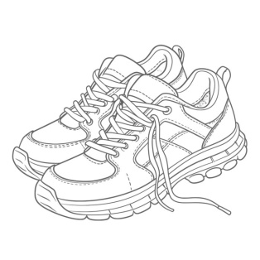  (PikBest,2023) | 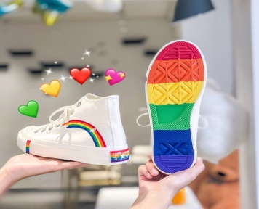  (AOSIG, 2021) | 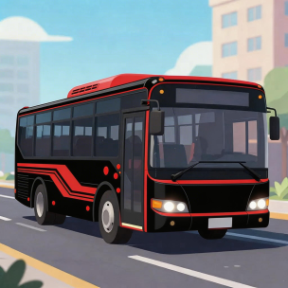 | 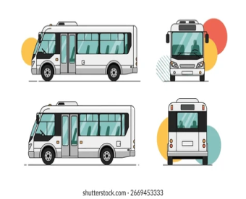  (shutterstock,2025)

The colour palette will reflect a modern and fashionable sneaker brand:
- Black – stylish and modern
- White – clean and simple
- Red – bold and energetic
These colours are commonly associated with sneaker and street wear brands.

Typography
Fonts used on the website will be modern and easy to read:
- Heading font: Bold sans-serif font
- Body text: Simple readable font

Layout and Design
The website design will be:
- Modern and visually appealing
- Mobile-friendly
- Easy to navigate
- Image-focused to highlight sneakers

User Experience Considerations
The website will ensure:
- Clear navigation menus
- Fast loading speed
- Easy viewing of sneaker products
- Mobile responsiveness
- Clear contact information (we do the web, 2025)

Low-Fidelity Wireframes (Description)

Homepage Layout
Top section:
- Logo
- Navigation bar (Home | About | Collection | Locations | Contact)
Middle section:
- Featured sneaker images
- Promotional banner
Bottom section:
- Social media links
- Contact information

6. Technical Requirements

Domain Name
Possible domain names:
- www.sneakerbussa.co.za

Hosting
Possible hosting providers include:
- Afrihost
- HostAfrica

Programming Languages
The website will be built using:
- HTML – website structure

7. Timeline and Milestones

Phase | Task | Time
Week 1 | Research and planning | 5 days
Week 2 | Design layout and wireframes | 1 week
Week 3 | Website development | 3 weeks
Week 4 | Testing and improvements | 5 weeks
Week 5 | Final submission and presentation | 2 months

8. Budget Estimate
Item | Estimated Cost
Domain registration | R1500 – R2500 per year
Website hosting | R70 – R150 per month
Website development | R2,000 – R5,000
Maintenance | R500 per year

Estimated First-Year Cost
Approximately R250000 – R550000

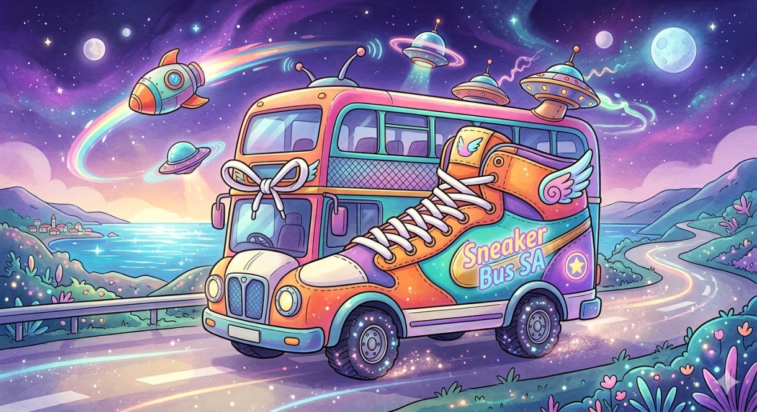

Reference list
AOSIG, 2021. Stylish Rainbow Print High Top Canvas Shoes. [Image online]. Available at: < https://aosig.com/products/stylish-rainbow-print-high-top-canvas-shoes?variant=50322524143938&pins_campaign_id=626757922172&utm_campaign=626757922172&utm_medium=PaidSocial&utm_source=Pinterest&utm_content=2680089344830&pp=0&epik=dj0yJnU9N19xMk1XY2FRcFlNNWFjQmRVa2ZyMHB1UUswTnpuWWUmcD0xJm49Wml4dEFqajMwemRXdGRUclVMWHgtQSZ0PUFBQUFBR20wS280 > [Accessed
Pikbest, 2023. Outline Sketch Colouring Page of Running Shoes Drawing Vector. [Image online] Available at: < https://pikbest.com/png-images/outline-sketch-coloring-page-of-running-shoes-drawing-vector_10476314.html?utm_source=Pinterest&utm_medium=organic > [26 April 2023].
Shatterstock, 2025. Modern city commuter mini bus vehicle transport design. [Image online]. Available at: < https://www.shutterstock.com/image-vector/modern-city-commuter-mini-bus-vehicle-2669453333?trackingId=a3fdfb8c-477f-4ae6-a2d0-c1fcb8f2d637&listId=searchResults > [Accessed 24 August 2025].
We do the web, 2025. The Importance of Clear Website Navigation Enhancing User Experience and Conversions. [Online] Available at: < https://wedotheweb.co.za/the-importance-of-clear-website-navigation-enhancing-user-experience-and-conversions-2/ > [Accessed 22 December 2025].

